

**SANYO SA-KC22BG3**

**Rs. 122,000/-**

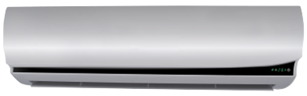

**Product Features**

* Easy Clean Panel
* Remote Control Pocket
* Three Minutes Protection
* Rust Resistant Cabinet
* Reserved Air Outlet

**Specification**

**Type** Wall Mounted Split AC

**Cooling (Btu/h)** 51000

**Voltage (V)** 220-240

**Power Input (W)** 4800

**EER (Btu/W-h-W/W)** 6.4-2.75